Patricia Caroline(916304)

Day 64 – Hands on 1

1. Logging

HomeController.cs

using Logging.Filter;

using Logging.Models;

using Microsoft.AspNetCore.Mvc;

using Microsoft.Extensions.Logging;

using System;

using System.Collections.Generic;

using System.Diagnostics;

using System.Linq;

using System.Threading.Tasks;

namespace Logging.Controllers

{

public class HomeController : Controller

{

[MyExceptionFilter]

public IActionResult Index()

{

int a = 5;

int b = 0;

int divison = a / b;

ViewBag.Message = "The Division is: " +divison;

return View();

}

public IActionResult Privacy()

{

return View();

}

}

}

MyExceptionFilter.cs

using log4net;

using Microsoft.AspNetCore.Mvc;

using Microsoft.AspNetCore.Mvc.Filters;

using System;

using System.Collections.Generic;

using System.Linq;

using System.Threading.Tasks;

namespace Logging.Filter

{

public class MyExceptionFilter : ExceptionFilterAttribute, IExceptionFilter

{

private readonly ILog _logger = LogManager.GetLogger(typeof(MyExceptionFilter));

public override void OnException(ExceptionContext context)

{

_logger.Error(context.Exception.Message);

context.ExceptionHandled = true;

context.Result = new ViewResult() { ViewName = "CustomErrors" };

}

}

}

CustomErrors.cshtml

@*

For more information on enabling MVC for empty projects, visit https://go.microsoft.com/fwlink/?LinkID=397860

*@

@{

ViewBag.Title = "Error";

}

<div style="background-color: #A52A2A; color: White; height: 10px;">

</div>

<div style="background-color: #F5F5DC; color: White; height: 170px;">

<div style="padding:20px;">

<h3 style="color: Black;">

Application Custom Error:

</h3>

<h4 style="color: Black;">

Sorry, an Divide by Zero error occurred while processing your request.

</h4>

<br />

<br />

</div>

</div>

<div style="background-color: #A52A2A; color: White; height: 20px;">

</div>

OUTPUT

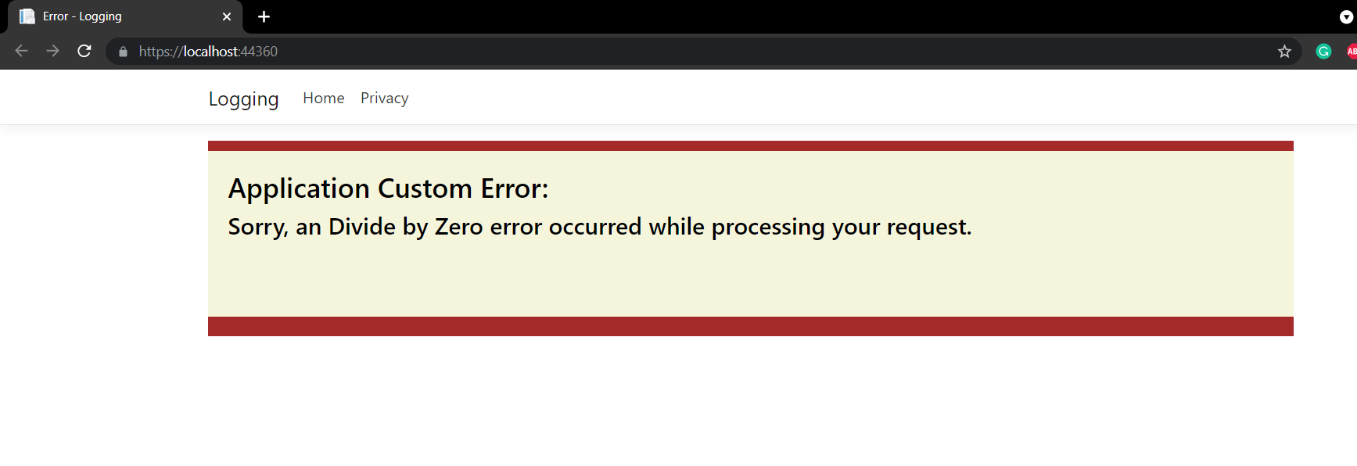

1. Log4Net usage for logging

HomeController.cs

using log4net;

using System;

using System.Collections.Generic;

using System.Linq;

using System.Web;

using System.Web.Mvc;

namespace Log4Net.Controllers

{

public class HomeController : Controller

{

private static readonly ILog Log = LogManager.GetLogger(typeof(HomeController));

public ActionResult Index()

{

try

{

Log.Debug("Log4Net usage for logging in ASP.NET MVC");

Log.Info("First");

Log.Warn("Second");

throw new NullReferenceException();

}

catch (Exception exp)

{

Log.Error("Error");

Log.Fatal("Fatal");

}

return View();

}

public ActionResult About()

{

ViewBag.Message = "Your application description page.";

return View();

}

public ActionResult Contact()

{

ViewBag.Message = "Your contact page.";

return View();

}

}

}

Global.asax.cs

using System;

using System.Collections.Generic;

using System.Linq;

using System.Web;

using System.Web.Mvc;

using System.Web.Optimization;

using System.Web.Routing;

namespace Log4Net

{

public class MvcApplication : System.Web.HttpApplication

{

protected void Application_Start()

{

log4net.Config.XmlConfigurator.Configure();

AreaRegistration.RegisterAllAreas();

FilterConfig.RegisterGlobalFilters(GlobalFilters.Filters);

RouteConfig.RegisterRoutes(RouteTable.Routes);

BundleConfig.RegisterBundles(BundleTable.Bundles);

}

}

}

1. Create a .Net core web application with a controller that is scaffolded with Entity framework options.

HomeController.cs

using AccountDetails.Models;

using Microsoft.AspNetCore.Mvc;

using Microsoft.EntityFrameworkCore;

using Microsoft.Extensions.Logging;

using System;

using System.Collections.Generic;

using System.Diagnostics;

using System.Linq;

using System.Threading.Tasks;

namespace AccountDetails.Controllers

{

public class HomeController : Controller

{

private AccountDbContext context;

public HomeController(AccountDbContext dbContext)

{

context = dbContext;

}

public async Task<IActionResult> Index()

{

List<Account> accList = await context.Accounts.ToListAsync();

return View(accList);

}

public IActionResult Create()

{

return View();

}

[HttpPost]

[ValidateAntiForgeryToken]

public async Task<IActionResult> Create([Bind("AccountId,AccountName")] Account obj)

{

if (ModelState.IsValid == true)

{

await context.Accounts.AddAsync(obj);

context.SaveChanges();

}

else

{

return NotFound();

}

return RedirectToAction("Index");

}

public async Task<IActionResult> Edit(int id)

{

Account obj = await context.Accounts.FindAsync(id);

return View(obj);

}

[HttpPost]

[ValidateAntiForgeryToken]

public async Task<IActionResult> Edit([Bind("AccountId,AccountName")] Account obj)

{

if (ModelState.IsValid == true)

{

context.Update(obj);

await context.SaveChangesAsync();

}

else

{

return NotFound();

}

return RedirectToAction("Index");

}

public async Task<IActionResult> Delete(int id)

{

Account obj = await context.Accounts.FindAsync(id);

return View(obj);

}

[HttpPost]

[ActionName("Delete")]

[ValidateAntiForgeryToken]

public async Task<IActionResult> DeleteConfirm(int id)

{

Account obj = await context.Accounts.FindAsync(id);

context.Accounts.Remove(obj);

await context.SaveChangesAsync();

return RedirectToAction(" Index ");

}

}

}

AccountDbContext.cs

using Microsoft.EntityFrameworkCore;

using System;

using System.Collections.Generic;

using System.Linq;

using System.Threading.Tasks;

namespace AccountDetails.Models

{

public class Account

{

public int AccountId { get; set; }

public string AccountName { get; set; }

}

public class AccountDbContext:DbContext

{

public DbSet<Account> Accounts { get; set; }

public AccountDbContext(DbContextOptions<AccountDbContext> options):base(options)

{

}

}

}